Noncustodial Parent Choices: A Comprehensive Guide

January 2020

TABLE OF CONTENTS

OVERVIEW OF GUIDE ...............................................................................................................................................4
PART A – POLICY AND REQUIREMENTS ............................................................................................................6

A-100: BACKGROUND.................................................................................................................................................................. 6

A-101: Applicable Contract Authorities ............................................................................................................... 6
A-102: NCP Choices Program Goals ....................................................................................................................... 6
A-103: Funding............................................................................................................................................................... 6
A-104: Target Population .......................................................................................................................................... 7
A-105: Results ................................................................................................................................................................. 7
A-200: DEFINITIONS OF NCP CHOICES ACRONYMS AND TERMS ........................................................................................ 8
A-300: NCP CHOICES PROGRAM RESPONSIBILITIES.............................................................................................................. 8

A-301: TWC—Responsibilities ...................................................................................................................................11
A-302: Office of the Attorney General—Responsibilities.................................................................................12
A-303: Local Workforce Development—Board Responsibilities ..................................................................12
A-304: Workforce Solutions Offices—Responsibilities .................................................................................13
A-305: All Parties—Responsibilities ....................................................................................................................13
A-306: NCP Participation—Requirements............................................................................................................13

A-400: APPEALS OF NCP CHOICES ACTIVITIES AND SUPPORT SERVICES DECISIONS .................................................. 14
A-500: DISCRIMINATION COMPLAINTS ................................................................................................................................. 14
A-600: GEOGRAPHIC COVERAGE ............................................................................................................................................ 14

PART B – OPERATIONS ......................................................................................................................................... 16

B-100: CASE MANAGEMENT............................................................................................................................................ 16

B-101: NCP Choices Process ....................................................................................................................................17
B-102: Intake ................................................................................................................................................................19
B-103: Workforce Orientation ...............................................................................................................................20
B-104: Assessment.......................................................................................................................................................21
B-105: Employment Planning ................................................................................................................................21
B-106: Employment Services and Activities ......................................................................................................22

B-106.a: Job Readiness................................................................................................................................................. 22
B-106.b: Job Search........................................................................................................................................................ 23
B-106.c: Work Experience ........................................................................................................................................ 23
B-106.d: On-the-Job Training.................................................................................................................................... 23
B-106.e: Subsidized Employment ........................................................................................................................... 24
B-106.f: Unsubsidized Employment ...................................................................................................................... 24
B-106.g: Unsubsidized Self-Employment............................................................................................................ 24
B-106.h: Vocational Educational Training.......................................................................................................... 25
B-106.i: Educational Services ................................................................................................................................... 26
B-106.j: Community Service ...................................................................................................................................... 26
B-106.k: Postemployment Services........................................................................................................................ 27

B-107: Work Opportunity Tax Credit and Fidelity Bonding.......................................................................28

B-200: SUPPORT SERVICES ..................................................................................................................................................... 28

B-201: Transportation Services .............................................................................................................................29
B-202: Work-Related Expenses..............................................................................................................................29
B-203: Nonmonetary Incentives for NCP Choices Participants.................................................................29
B-204: Nonrecurrent Short-Term Benefits........................................................................................................30

B-300: VERIFICATION AND DOCUMENTATION REQUIREMENTS ....................................................................................... 30

B-301: TWIST Instructions ......................................................................................................................................30

B-301.a: TWIST Program Detail Screen ............................................................................................................... 31
B-301.b: TWIST Program Summary Tab ............................................................................................................. 32
B-301.c: TWIST Characteristics Tab ...................................................................................................................... 33
B-301.d: TWIST Education Tab ................................................................................................................................ 34
B-301.e: TWIST Services Tracking Tab................................................................................................................. 35
B-301.f: TWIST Service Information Screen ....................................................................................................... 36
B-301.g: TWIST Fund Detail Fields ........................................................................................................................ 37

B-301.g(1): Allowable Services............................................................................................................ 38

B-400: CASE CLOSURE ............................................................................................................................................................. 38

B-401: Request to Remove ......................................................................................................................................40
B-402: Administrative Removals...........................................................................................................................41
B-403: Planned Gap in Service ...............................................................................................................................41
B-404: Reasons for Removal ...................................................................................................................................42

B-404.a: Meets NCP Choices Program Requirements................................................................................... 42
B-404.b: Noncompliance with NCP Choices Program Requirements ................................................... 42
B-404.c: NCP Choices Participant Becomes Ineligible or Unable to Participate .............................. 43

B-404.c(1): TWIST Program Summary Tab .................................................................................. 45

B-500: NCP CHOICES PERFORMANCE MEASURES.............................................................................................................. 46
B-600: TWIST WEB REPORTS .............................................................................................................................................. 47

PART C – FREQUENTLY ASKED QUESTIONS .................................................................................................. 48

C-100: NCP CHOICES ORDERS AND ELIGIBILITY ................................................................................................................ 48
C-200: NCP CHOICES PROCEDURES AND TWIST DOCUMENTATION ............................................................................. 49
C-300: ADDITIONAL SERVICES OFFERED FOR NCP CHOICES PARTICIPANTS ................................................................ 50

PART D – LIST OF REVISIONS ............................................................................................................................. 51

Overview of Guide
Purpose

The purpose of this guide is to provide:

• policies and procedures for the Noncustodial Parent (NCP) Choices program; and
• guidance and information on assisting NCP Choices participants in their efforts to obtain and retain employment and meet their child support obligations.

Objectives

The objectives of this guide are to:

• communicate expectations for NCP Choices participation and program requirements;
• ensure service consistency; and
• improve links between partner agencies.

Target Audience

The target audience for this guide is:

• Workforce Solutions Office staff;
• Local Workforce Development Board (Board) staff; and
• Texas Workforce Commission (TWC) staff.

Parts of the Guide

The numbering system for this guide is based on alphabetical divisions, with numerical subdivisions.

Part A: Policy and Requirements

Part B: Operations

Part C: Frequently Asked Questions

Part D: List of Revisions

Changes to Content

TWC maintains the NCP Choices guide online to provide access to current statewide policy and guidance information.

Updates to the guide will be issued through WD Letters and Technical Assistance Bulletins, which will indicate that the guide has been revised to incorporate new information. Part D of the guide, List of Revisions, contains the revision date, the section revised, and a brief explanation of the specific revision.

List of Acronyms

AEL - Adult Education and Literacy

ACF - Administration for Children and Families AIW - Administrative Income Withholding Board - Local Workforce Development Board COLTS - Choices Online Tracking System CSRP - Child Support Review Process
EST - Establishment case
ENF - Enforcement case
MREV - Motion to Revoke

MTRP - Motion to Revoke Probation

NCP - noncustodial parent

NPA case - non–public assistance case

OAG - Office of the Attorney General

OCSE - Office of Child Support Enforcement

OJT - on-the-job training

TABE - Test of Adult Basic Education

TANF - Temporary Assistance for Needy Families

TWC - Texas Workforce Commission

TWIST - The Workforce Information System of Texas WIOA - Workforce Innovation and Opportunity Act workforce area - local workforce development area
WOTC - Work Opportunity Tax Credit

Part A – Policy and Requirements

A-100: Background

A-101: Applicable Contract Authorities
The Noncustodial Parent (NCP) Choices program is authorized under Texas Labor Code §302.0035, the Temporary Assistance for Needy Families (TANF) State Plan, and the following federal statutes and regulations:

TANF provisions in the Social Security Act, 42 United States Code (USC) §§601–619, as amended or supplemented by:

• Personal Responsibility and Work Opportunity Reconciliation Act of 1996, 42 USC §601 et seq.;
• Balanced Budget Act of 1997 (PL 105-33);
• Deficit Reduction Act of 2005 (PL 109-171); and
• TANF federal regulations, 45 Code of Federal Regulations (CFR) Parts 260–265.

A-102: NCP Choices Program Goals
Initiated in August 2005, the NCP Choices program is a collaborative effort of the Texas Workforce Commission (TWC), the Office of the Attorney General (OAG) of Texas, Local Workforce Development Boards (Boards), Workforce Solutions Office staff, and family court judges. The program targets low-income unemployed or underemployed NCPs who are behind on their child support payments or have had a child support obligation established.

Mirrored after TWC’s Choices employment and training program for TANF recipients, the goal of the NCP Choices program is to help NCPs overcome substantial barriers to employment and career advancement while becoming economically self-sufficient and making consistent child support payments.

The success of the NCP Choices program is largely attributable to four core elements:

1. Court-ordered program participation. Failure to participate leads to “swift and certain consequences,” up to, and including, jail time;

2. Presence of Workforce Solutions Office staff at the court to meet with NCPs immediately after being ordered into the program;

3. Intensive case management by Workforce Solutions Office staff, including weekly in-person contact until NCPs enter employment, and monthly verification of continued employment; and

4. Close communication with program partners regarding NCPs’ participation and progress in the program.

A-103: Funding
Funded primarily with TWC’s TANF funds, the NCP Choices program is modeled on previous NCP employment programs and Texas’ TANF employment and training program, Choices. NCPs who are ordered into the program by the court system either participate willingly in the program or are subject to consequences determined by the court.

Additionally, OAG has provided funding to expand the program to serve low-income non–public assistance cases (NPA cases) with child support arrears as well as cases that are beginning to establish child support.

A-104: Target Population
To be eligible for the NCP Choices program, an NCP must:

• have an open child support case;
• be unemployed or underemployed;
• reside in the geographical area served by the participating Board;
• be legally able to work in the United States;
• have an OAG-issued child support order; and
• have been ordered by a court to participate in the program.

Beginning February 2013, eligibility criteria were expanded to include NPA cases as well as public assistance cases.

Only NCPs who meet all of the criteria listed above can participate in the NCP Choices program. NCPs cannot be referred to the program by Workforce Solutions Office staff or from other programs, and former participants cannot resume participation without a new court order. A noncustodial or custodial parent who is not eligible for the program can still access workforce services as a universal customer through a Workforce Solutions Office.

A-105: Results
Despite the fact that this is one of the hardest-to-serve populations, the NCP Choices program has seen positive employment, job retention, and child support results. The following program information was collected between August 2005 and April 2019:

• More than 40,000 NCPs served
• 46.33 percent of participating NCPs entered employment during SFY’18
- 72.47 percent of participating NCPs retained employment for at least six months during SFY’18
Additionally:

• custodial parents are 21 percent less likely to receive TANF benefits;
- Over $479 million was collected and paid towards child support; and
• more than $6 million in child support was collected during SFY’18.

A-200: Definitions of NCP Choices
IV-D—the section of the Social Security Act that outlines the federal regulations relating to child support collections.

IV-D Court—the court that handles Title IV-D cases related to paternity and child support.

Acknowledgment of Paternity—when both parents sign an Acknowledgment of Paternity, and it is filed with the Bureau of Vital Statistics, the biological father becomes the legal father. Once paternity has been established, the father’s name is placed on the birth certificate. A court may then order the father to pay child support and grant him the right to visitation or possession of his child.

Administrative Income Withholding (AIW)—child support that is automatically taken out of an NCP’s wages (also known by his or her employer as wage garnishment or an Income Withholding Order) and sent to the Texas State Disbursement Unit.

Administrative removal—a removal process that allows child support offices to remove a noncompliant NCP Choices participant from the program without bringing the NCP back to court and without punitive consequences (e.g., arrest warrant/capias, motion to revoke, jail sentence).

Arrears—unpaid child support debt.

Assessment—an in-depth evaluation of employability, educational history, vocational and educational skills, literacy levels, work experience, criminal history, family circumstances, special circumstances, and support service needs.

A-200: Definitions of NCP Choices (continued)
Capias—a writ (court order) issued by a court directing an officer to arrest the person named; it is also known as an arrest warrant or bench warrant.

Child Support Review Process (CSRP)—a quasi-administrative way for parents to resolve legal issues about their child support without going to court. Parents meet with a child support officer to negotiate an order. Once an agreement is reached, a CSRP order is filed with the court and reviewed by a judge. After the judge has signed it, a CSRP order is legally binding and will be enforced just as any order obtained through a court proceeding.

Choices Online Tracking System (COLTS)—the OAG web-based tracking and reporting system shared by TWC, Boards, Workforce Solutions Office staff, and OAG that is used to store and retrieve real-time NCP Choices participant data. Approved users can access the COLTS system at OAG COLTS Login. OAG also provides related resources and information through COLTS, including:

• COLTS User Guide;
• Authorization to Release Information form; and
• Annual and monthly statewide performance reports.

Compliance hearing—a court hearing that includes review of an NCP’s compliance with NCP Choices program requirements. Compliance hearings are set at the judge’s discretion and are typically scheduled for enforcement cases at 30, 60, or 90 days—depending on the court—from the date an NCP is ordered into NCP Choices.

Custodial parent—the individual who has primary care and custody of the child.

Deferred commitment—a court order in which an NCP’s jail sentence (commitment) is deferred to a future court date, at which time the NCP may begin serving his or her jail sentence.

Domestic Relations Office—county court office that provides information and services related to child support orders, including collections, support and possession of and access to children, and enforcement of orders for child and medical support.

Employment plan—a plan of action developed by Workforce Solutions Office staff with the NCP Choices participant and based on assessments of the NCP’s skills, strengths, and abilities, with the goal of self-sufficiency through employment. The employment plan must include postemployment service strategies to assist the individual with employment retention and advancement.

A-200: Definitions of NCP Choices (continued)
Employment Retention—when an NCP is employed within the 1st calendar quarter after exit and employed in the 2nd and 3rd calendar quarters after exit.

Enforcement hearing—court hearing in which solutions to obtain child support payments are applied. Enforcement hearings are not held unless the NCP has past due, unpaid child support payments, or is considered to be in arrears. This hearing determines eligibility for the NCP Choices program.

Entered Employment—when an NCP obtains employment by the end of the 1st calendar quarter after exit.

Establishment hearing—court hearing that establishes paternity and child support payment levels.

Income Withholding Order—a court order requiring child support to be automatically taken out of an NCP’s wages by his or her employer and sent to the Texas State Disbursement Unit; it is also known as wage garnishment or administrative income withholding (AIW).

Local Workforce Development Board (Board)—the organization responsible for the planning and oversight of workforce services within its designated local workforce development area (workforce area).

Motion to Revoke (MREV)—the revocation of a suspended commitment order. If an NCP does not comply with his or her child support order, OAG submits an MREV requesting that the judge revoke the suspended commitment and the MREV may be accompanied by the court’s issuance of an arrest warrant for the NCP. It is also known as a Motion to Revoke Probation or an MTRP.

NCP Choices participant—an individual who is participating in the NCP Choices program as directed by an enforcement or establishment court order.

Non–Public Assistance (NPA) case—a case in which an NCP is not associated with any individual receiving public assistance.

Noncompliance—noncooperation with NCP Choices program guidelines, including a lack of participation in work search activities, lack of response to outreach notices, and nonpayment of child support.

A-200: Definitions of NCP Choices (continued)
Noncustodial parent (NCP)—an individual who does not have primary care or custody of his or her child and is required to pay child support; also known as the obligor.

Obligor—the individual responsible for paying child support; also known as the NCP.

Office of the Attorney General (OAG)—the state agency serving as legal counsel for the State of Texas; among other duties, OAG is charged with providing services to parents/guardians who wish to obtain or provide support for their children.

Suspended commitment—the court order may find the NCP in contempt and enter a jail sentence but suspend the sentence before the NCP begins serving the time. This is similar to placing an individual on probation. The court may set whatever terms it deems appropriate for the conditions of the suspended sentence including reporting to a probation officer or participating with the NCP Choices program.

Texas Child Support Enforcement System (TXCSES)—OAG’s automated data processing system used for storing and retrieving NCP case information and status.

The Workforce Information System of Texas (TWIST)—TWC’s automated data processing and case management system for the Texas workforce system.

Work activities—for the purposes of the NCP Choices program, work activities include job readiness, job search, vocational and educational training, work experience, on-the-job training, subsidized employment, unsubsidized employment, unsubsidized self-employment, and community service.

Workforce Orientation for Applicants (WOA)—a workforce orientation that includes information on the options and services available through the Texas workforce system to assist job seekers in obtaining employment.

A-300: NCP Choices Program Responsibilities

A-301: TWC Responsibilities
TWC:
• issues rules, policies, and guidelines for Noncustodial Parent (NCP) Choices services;
• contracts with Boards to provide NCP Choices services;
• conducts regular site visits, in coordination with OAG staff, to NCP Choices program areas to meet with Board, Workforce Solutions Office, and OAG staff to review program progress, and identify necessary program enhancements and best practices;
• provides training and technical assistance to participating Board and Workforce Solutions
Office staff as necessary and appropriate;
• analyzes and monitors fiscal and performance activities on an ongoing basis; and
• coordinates with OAG to identify and implement programmatic enhancements to NCP Choices.

A-302: Office of the Attorney General Responsibilities
OAG:

• identifies NCPs who are eligible for participation in NCP Choices;
• communicates NCP Choices benefits and consequences of non-compliance to CPs and NCPs, and parties’ attorneys during court;
• prepares appropriate child support court orders, including provisions to participate in NCP Choices;
• uses Choices Online Tracking System (COLTS) to maintain a comprehensive log of participants ordered into NCP Choices and of participant outcomes, including child support payments;
• coordinates with county courts to set establishment and enforcement cases on the court dockets;
• responds to Workforce Solutions Office staff requests for removal of noncompliant NCP’s and facilitates through judicial or administrative actions the removal of an NCP;
• participates in monthly meetings with Board and Workforce Solutions Office staff to review NCP Choices program progress and to identify program enhancements;
• provides COLTS access and training to all COLTS users;
• analyzes program outcomes on an ongoing basis; and
• coordinates with TWC to identify and implement programmatic enhancement to NCP Choices.

A-303: Local Workforce Development Board Responsibilities
Boards must design systems, subcontracts, and structures supporting the provision of services and supporting strategies reasonably calculated to achieve NCP Choices program goals. Boards must:

• provide ongoing oversight and management of the NCP Choices program;
• analyze and monitor fiscal and grant award performance activities on an ongoing basis;
• provide technical assistance to Workforce Solutions Office staff as necessary and appropriate;
• develop corrective action plans as needed to improve program performance;
• coordinate monthly NCP Choices meetings with OAG and Workforce Solutions Office staff to discuss and review program progress and to identify necessary program enhancements;

• develop a memorandum of understanding with OAG that outlines both parties’ program roles and responsibilities; and
• comply with all WD Letters and TWC guidance relating to the NCP Choices program.

A-304: Workforce Solutions Offices—Responsibilities
Boards must ensure that Workforce Solutions Offices designate a sufficient number of staff to serve as case managers responsible for:

• attending court hearings to enroll eligible participants in the NCP Choices program and being available in subsequent hearings to provide testimony as needed;
• serving eligible participants by providing allowable employment services that mirror Choices employment services;
• accurately documenting case activity, services, employment, wages, and court order compliance within three business days in TWIST and COLTS;
• coordinating program activities with TWC, Boards, OAG, and the local court system;
• co-enrolling participating NCPs in other workforce programs, as necessary and appropriate;
• participating in monthly NCP Choices staff meetings with Board and OAG staff to review program progress and identify program enhancements; and
• complying with all WD Letters and TWC guidance relating to the NCP Choices program.

A-305: All Parties—Responsibilities
All parties must:

• formalize processes for sharing information regarding NCP Choices outcomes for reporting requirements, as appropriate and allowable;
• promote joint planning to include processes and procedures;
• provide coordinated services that address barriers to assisting participants with finding and retaining employment and payment of child support; and
• maintain the confidentiality of applicant information and use applicant data only for the administration of the parties’ appropriate programs.

A-306: NCP Participation Requirements
At a minimum, NCPs must:

• participate in work activities for an average of 30 hours per week;
• meet in person with their NCP Choices case manager weekly, until employed, concerning NCP Choices activities;
• complete and return to the NCP Choices case manager all required forms concerning NCP Choices activities and program participation;
• report to employers when referred;
• accept job offers at the earliest opportunity; and
• submit documentation verifying continued employment each month for six months.

A-400: Appeals of NCP Choices Activities and Support Services Decisions
Boards must ensure that Workforce Solutions Office staff providing NCP Choices services informs NCPs of their right to appeal a decision related to NCP Choices activities and support services. Boards must establish policies to inform individuals of their right to file an appeal if a determination adversely affects the type and level of services provided by the Board or its designee. This can be accomplished by:

• verbally informing NCPs of their appeal rights during employment planning meetings;
• distributing materials, including leaflets and brochures, during employment planning meetings at the Workforce Solutions Office, that inform NCPs of their right to appeal; and
• posting signs in the Workforce Solutions Office regarding the right to appeal.

Boards must ensure that NCPs are provided with the Workforce Solutions Office address, name of a contact person, and a specific time period for filing an appeal. NCPs can appeal a decision under the hearings process set forth in TWC’s Integrated Complaints, Hearings, and Appeals rules at 40 TAC,
Chapter 823 Rules.

A-500: Discrimination Complaints
NCPs alleging discrimination on the basis of age, race, color, national origin, or physical or mental disability have a right to file a written complaint of alleged discriminatory acts within 180 calendar days from the date of the alleged discriminatory act. NCPs must submit complaints to the following address:

Texas Workforce Commission
Sub-recipient and Equal Opportunity Monitoring
101 East 15th Street, Room 242T Austin, Texas 78778-0001

Boards must ensure that Board or Workforce Solutions Office staff advises NCPs who express an interest in filing a discrimination complaint of their right to file a complaint and of the complaint procedures.

A-600: Geographic Coverage
As of December 2015, NCP Choices programs operate in 21 local workforce development areas.

NCP Choices Service Delivery Areas

LWDA  # | Board | Counties Served | Child Support Offices

LWDA  # | Board | Counties Served | Child Support Offices
1 | Panhandle | Deaf Smith, Potter, and Randall | 103
2 | South Plains | Hale, Hockley, Lubbock, and  Terry | 102 and 161
4 | North Central | Collin and Denton | 413 and 903
5 | Tarrant County | Tarrant | 902, 904, 905, 906, and  909
6 | Dallas County | Dallas | 403, 406, 407, 409, and  411
8 | East Texas | Gregg, Harrison, Henderson,  and Van Zandt | 503 and 506
9 | West Central | Taylor | 105
10 | Upper Rio  Grande | El Paso | 807, 808, and 806
14 | Capital Area | Travis | 702 and 703
15 | Rural Capital  Area | Williamson | 703
16 | Brazos Valley | Brazos | 706
17 | Deep East | Angelina and Nacogdoches | 504
18 | Southeast | Jefferson, Hardin, and Orange | 502 and 505
19 | Golden Crescent | Calhoun, Goliad, Jackson,  DeWitt, and Victoria | 707
20 | Alamo | Bexar | 219, 218, and 221
21 | South Texas | Webb | 305
22 | Coastal Bend | Nueces | 304
23 | Lower Rio | Hidalgo | 316

LWDA  # | Board | Counties Served | Child Support Offices
 | Grande Valley
24 | Cameron County | Cameron | 307 and 308
26 | Central Texas | Bell | 704
28 | Gulf Coast | Brazoria, Galveston, and Harris | 603 (Galveston/Brazoria),  613, and 615

Part B – Operations

B-100: CASE MANAGEMENT
The role of Workforce Solutions Office staff in the Noncustodial Parent (NCP) Choices program is to eliminate NCPs’ barriers to employment so they can enter stable employment. Intensive case management is vital to ensuring that NCPs do not slip through the cracks.

Active participation is a basic requirement of NCP Choices. NCPs are required to participate in work activities for an average of 30 hours per week, as directed by Workforce Solutions Office staff.

Local Workforce Development Boards (Boards) must ensure that Workforce Solutions Office staff maintains:

• in-person contact, at least weekly, with NCPs until they enter employment; and
• monthly contact with NCPs for six months to track retention and provide postemployment services, as needed, after they enter employment. Once an NCP becomes employed, monthly contact does not have to be in person.

To provide effective case management, it is critical that Boards ensure that each Workforce Solutions Office staff member:

• carries a manageable NCP caseload (what is considered a manageable caseload will vary depending on the local workforce development area’s size, level of services, and number of NCPs receiving employment retention services);
• develops a thorough awareness of the Office of the Attorney General’s (OAG) and the local court system’s procedures and policies; and
• maintains ongoing communication with OAG staff regarding NCPs’ program participation and progress.

Boards may coordinate information sharing and training with local OAG staff. Additional technical assistance may be provided by Texas Workforce Commission (TWC) or OAG state staff.

In courts that hold compliance or review hearings, the court schedules and conducts judicial monitoring of cases. Boards must ensure that Workforce Solutions Office staff attends NCP hearings in conjunction with OAG, and provides testimony, when requested, regarding NCP compliance, noncompliance, or employment.

Boards must be aware that Workforce Solutions Office staff is not responsible for ensuring that NCPs make child support payments; however, monitoring and encouraging NCPs to make payments can be a critical part of an NCP’s successfully meeting the terms of the court order.

B-101: NCP Choices Process
The NCP Choices process is as follows:

1. OAG identifies eligible NCPs.
2. NCP appears for enforcement or establishment hearing.
3. If NCP does not sign the agreement for workforce services, then the NCP is monitored by OAG for continued payment of child support.
4. If NCP does sign agreement for workforce services, then.
5. Judge orders NCP into the program.
6. The NCP meets with Workforce Solutions Office staff at the court hearing, schedules an intake appointment, and obtains the required documentation.

Workforce Solutions Office staff provides workforce services to NCP by:

1. conducting intake (assessment, workforce orientation, and development of an employment plan that includes testing of the labor market);
2. completing The Workforce Information System of Texas (TWIST) Program Detail for each NCP ordered into the program; and
3. documenting employment services and activities.
4. If the NCP is employed, Workforce Solutions Office staff:
- verifies and records employment monthly; and
- provides regular status updates to OAG and the court.
5. If the NCP is not employed, Workforce Solutions Office staff:
- holds weekly, in-person meetings with the NCP;
- provides appropriate support and employment services;
- monitors NCP’s compliance and adherence to his or her employment plan;
- documents employment activities monthly; and
- provides regular status updates to OAG and the court.

Workforce Solutions Office staff and OAG monitor NCP for compliance. Program compliance means the NCP is participating in workforce services in accordance with his or her employment plan and is paying child support:

• If the NCP is not compliant: Workforce Solutions Office staff submits a request to remove to OAG in accordance with section B-400: Case Closure; or
• If the NCP is compliant: The case is ongoing until the NCP graduates from NCP Choices after six months of retained employment.

NCP Choices Program Process Flowchart

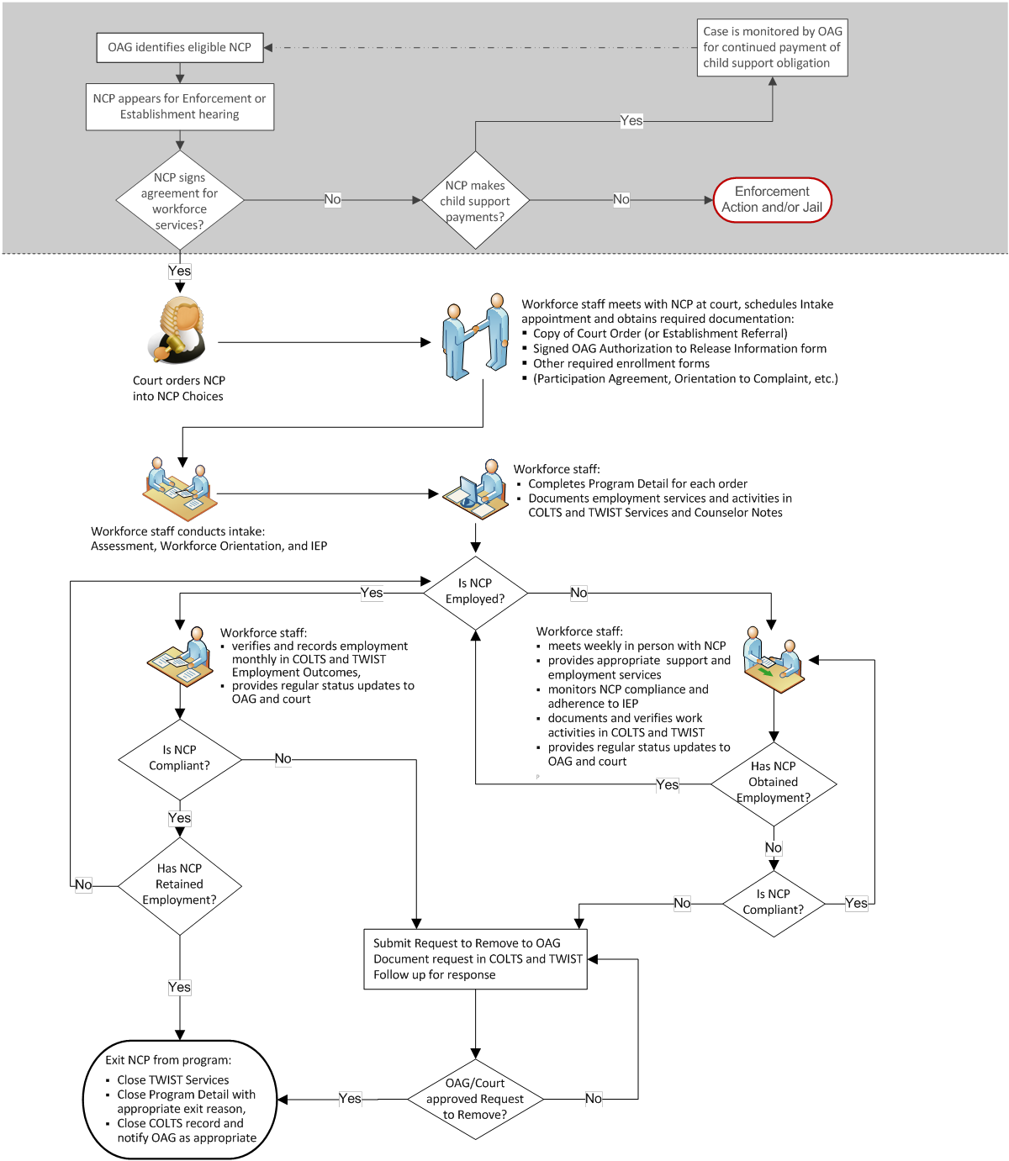

B-102: Intake
OAG identifies eligible NCPs and works with the court to set hearings for NCP cases on upcoming court dockets. Local OAG offices have monthly goals for the number of NCPs to be ordered into the NCP Choices program. The exact number may vary by site. Boards must ensure that Workforce Solutions Office staff does not outreach NCPs or determine eligibility.

Boards must ensure that Workforce Solutions Office staff attends NCP court hearings. (Professional dress and behavior in the courtroom is expected.)

Boards must be aware that Workforce Solutions Office staff attendance at NCP court hearings:

• allows for ongoing communication among judges, OAG, and Workforce Solutions Office staff;
• eliminates confusion about whether the individual has been ordered to participate in the NCP Choices program due to an enforcement or establishment case;
• enables staff to immediately obtain a copy of the court order; and
• provides staff with the opportunity to have immediate contact with the NCP, which reinforces the partnership among the judge, OAG, and staff, and gives staff the chance to introduce NCPs to the program when they are most receptive.

Upon mandate into the program by a judge, Boards must ensure that immediately after the NCP is ordered to participate in NCP Choices, Workforce Solutions Office staff meets with the NCP to:

• explain the consequences for noncompliance, the NCP Choices program requirements, and available workforce services;
• obtain a signed OAG Authorization to Release Information form (available in the Resource section of COLTS or from TWC technical assistance staff);
• schedule an initial appointment to meet again within one week of the court order date to complete a workforce orientation, initial assessment, and employment plan; and
• provide the NCP with a signed appointment letter for the initial appointment, which includes contact information for the NCP and Workforce Solutions Office staff.

Additionally, Boards may choose to have signed copies of other enrollment forms, such as the Workforce Participation Agreement, Orientation to Complaint Procedure, and other locally developed forms completed at court.

The court order does not have to be signed by the judge for Workforce Solutions Office staff to begin working with the NCP. However, it is best practice, when possible, to keep a signed copy of the court order in the NCP’s case file.

Boards must ensure that within one week of the court order date, Workforce Solutions Office staff has:

• received a copy of the court order mandating the NCP’s participation; and
• completed an initial intake with the NCP.

Boards must be aware that Workforce Solutions Office staff may complete the initial intake at court, but typically it is completed during the NCP’s first meeting with Workforce Solutions Office staff after being ordered to participate in the NCP Choices program. At the first meeting, Boards must ensure that Workforce Solutions Office staff:

• obtains signed copies of enrollment forms, Workforce Participation Agreement, Orientation to Complaint Procedures, and other locally developed forms if not completed at court;
• provides a workforce orientation;
• completes a comprehensive assessment of employment needs (including the need for support services);
• develops an employment plan with the NCP; and
• documents these services in TWIST and COLTS.

B-103: Workforce Orientation
The purpose of the workforce orientation is to inform NCPs of the services and tools available to facilitate their entry into the workforce. Boards must ensure that Workforce Solutions Office staff:

• allows NCPs to participate in a regularly scheduled Workforce Orientation for Applicants; or
• presents comparable information to help NCPs understand:
➢ the benefits and advantages of becoming employed;
➢ available workforce services and tools;
➢ individual and parental responsibility; and
➢ the likely consequences of noncompliance.

At a minimum, each workforce orientation must provide:

• NCP Choices program participation requirements;
• potential consequences of noncompliance with program participation requirements; and
• information on the following:
➢ How to find a job
➢ Local labor market information
➢ Job counseling, job search, and job referral assistance
➢ Availability of support services
➢ WorkInTexas.com
➢ Other available services, including:
o the Work Opportunity Tax Credit (WOTC);
o fidelity bonding;
o the Workforce Innovation and Opportunity Act (WIOA); and

o the Earned Income Tax Credit (EITC).
➢ Assistance with applications and résumés
➢ Interests, aptitude, and educational testing
➢ Books, magazines, or Internet links to careers and employers
➢ Resource room access (computers, phone, fax, etc.)

B-104: Assessment
Boards must ensure that Workforce Solutions Office staff performs initial and ongoing assessments to:

• determine the employability and job retention needs of all NCP Choices participants, including wage advancement and career development needs; and
• guide the development of an employment plan.

Boards may develop their own procedures and documentation requirements relating to assessments, provided the assessments identify an NCP’s:

• work experience;
• job interests and goals;
• support service needs;
• vocational and educational skills and training;
• pre-employment and postemployment skills development needs to determine the necessity of job-specific training; and
• individual and family circumstances that could create barriers to employment or participation in NCP Choices.

B-105: Employment Planning
Boards must ensure that Workforce Solutions Office staff jointly develops an employment plan with each NCP to identify the participant’s employment goals and the sequence of services and activities needed to transition to permanent employment. The employment plan is an agreement with the NCP, describing each party’s responsibilities.

Boards must ensure that Workforce Solutions Office staff:

• completes the initial employment plan no later than one week following the date of intake;
• includes the following elements in the employment plan:
➢ NCP’s education level, skills, abilities, and interests
➢ NCP’s obstacles or barriers to successful program participation and goal attainment
➢ NCP’s short-term employment goals, including testing the labor market
➢ NCP’s long-term employment goals, including career-advancement strategies
➢ Mutually agreed-upon strategies, services, and activities to be provided to assist the NCP in achieving his or her goals
➢ Progress updates

• prints, signs, and dates the employment plan with the NCP;
• provides a copy of the employment plan to the NCP;
• retains the original and any updates to the employment plan in the NCP’s case file; and
• enters employment plan development as a service into TWIST and checks that the
Counselor Notes in TWIST and COLTS reflect the elements of the employment plan. Boards must ensure that:
• the NCP and his or her case manager regularly review and update the employment plan, based on any changes in the NCP’s goals, objectives, needs, barriers, progress, or activities; and
• the case manager documents, reviews, and updates information in TWIST and COLTS
following each meeting with the NCP.

B-106: Employment Services and Activities
The services provided to NCPs mirror the services provided to Temporary Assistance for Needy Families recipients under TWC’s Choices program. The goal of NCP Choices services is to eliminate barriers to permanent full-time employment and earning self-sustaining wages.

Some local strategies to accomplish this goal include:

• collaborating with and co-enrolling NCPs in other programs when appropriate (WIOA, Self-Sufficiency Fund, targeted job training programs, apprenticeships, etc.);
• offering incentives, such as gift cards and gas cards, to encourage greater participation; and
• connecting with local employers for subsidized employment or on-the-job training (OJT)
opportunities.

Boards must be aware that NCP Choices participants are required to participate in at least an average of 30 hours of work activities per week until they enter full-time employment.

Boards must ensure that case managers are accessible to allow NCP Choices participants to submit job search documentation, report job search progress, and receive additional guidance.

Boards must ensure that the following employment and support services are provided, as appropriate, based on the Workforce Solutions Office staff’s assessment of an NCP’s skills, strengths, and barriers, and as described in the NCP’s employment plan.

B-106.a: Job Readiness
Boards may provide job readiness services to assist NCP Choices participants in seeking, obtaining, and retaining employment. Job readiness activities include:

• life skills;
• guidance and motivation for development of positive work behaviors for the labor market;
• job skills assessment;

• job counseling;
• interviewing skills and practice interviews; and
• assistance with applications and résumés.

B-106.b: Job Search
Boards must be aware that job search activities can be self-directed or staff-assisted and include:

• seeking and obtaining information on available jobs;
• attending job fairs and job clubs;
• contacting job referrals;
• applying or interviewing for job vacancies;
• contacting potential employers; and
• participating in job development services focused on active engagement of employers.

B-106.c: Work Experience
Work experience includes any work without pay or compensation that allows an individual to gain knowledge, training, or skills necessary to obtain employment. Boards must ensure that work experience is:

• similar in concept to OJT;
• in the private, for-profit sector;
• authorized on a case-by-case basis;
• expected to improve the employability of the individual;
• time-limited (as defined by the Board) and designed to move the recipient into unsubsidized employment;
• unsalaried, with designated hours, tasks, skills, and attainment objectives; and
• supervised daily by an employer, worksite supervisor, or designated representative.

B-106.d: On-the-Job Training
An employer provides OJT, on or off the worksite, to an NCP who is engaged in productive work in a job. Boards must ensure that OJT:

• provides knowledge or skills essential to the full and adequate performance of the job;
• provides the employer with reimbursement of a percentage of the NCP’s wage rate for the extraordinary costs of providing the training and additional supervision related to the training;
• is limited in duration as appropriate to the occupation for which the NCP is being trained, taking into account the content of the training, the prior work experience of the individual, and the service strategy of the individual;
• includes training specified by the employer (i.e., customized training);

• provides wages, benefits, and working conditions equal to those provided to the employer’s incumbent employees who have worked a similar length of time and performed a similar type of work; and
• is supervised daily by the employer, worksite sponsor, or service provider’s designated representative.

Boards are not required to procure employers for OJT and customized training.

However, if a Board chooses to offer OJT and customized training, it must establish local policies for identifying employers for OJT and customized training services.

B-106.e: Subsidized Employment
Subsidized employment is short-term, private-sector employment, either full time or part time, in which a portion of the individual’s wages is subsidized. It is designed to allow the individual to learn the skills necessary to transition into unsubsidized employment. A Board must not be the employer of record for NCPs enrolled in a subsidized employment activity. Employers cannot use subsidized employment to displace existing employees, and wages must be at least the federal minimum wage.

B-106.f: Unsubsidized Employment
Unsubsidized employment includes either full- or part-time employment in which wages are paid in full by the employer. If an NCP is not employed full time, Boards must ensure that he or she participates in additional employment activities to equal an average of 30 hours or more per week.

Full-time employment is:

• 30 hours per week or more, for which the individual receives wages or compensation from an employer or from self-employment; or
• weekly wages from an employer or from self-employment that are at least equal to 30 hours per week multiplied by the federal minimum wage.

B-106.g: Unsubsidized Self-Employment

Initial Verification of Established Self-Employment Enterprises
Boards must ensure that Workforce Solutions Office staff conducts initial verification of established self-employment enterprises and requires one of the following forms of documentation:

• Federal income tax forms or quarterly income reports, such as:
• Form 1040; or
• Schedule C, F, or SE federal income tax returns for the most recent tax year;
• One of the following to prove existence of the business:
• Property titles, deeds, or rental agreements for the place of business
• Recent business bank, phone, utility, or insurance bill

• Recent state sales tax return
• Business records that provide proof of income and expenditures, such as:
• copies of money orders or checks received, and lists of individuals/customers served (if available);
• personal wage records with third-party signed verification; or
• business plans.

Initial Verification of Prospective Self-Employment Enterprises
Boards must ensure that Workforce Solutions Office staff conducts initial verification of prospective self-employment enterprises and requires one of the following forms of documentation:

• Property titles or deeds for the place of business
• Rental agreement or letter from a property owner showing the customer plans to open a business
• Other evidence indicating the customer is preparing to open a business, such as:
• advertising, state tax registration, assumed name certificate;
• business plan; or
• bank account information.

Ongoing Verification of All Self-Employment Enterprises
Boards must ensure that Workforce Solutions Office staff verifies on an ongoing basis participants’ self-employment enterprises as participants submit the following:

- Documentation that provides information on the amount of income generated and the associated business expenses, which must include invoices signed by NCP Choices participants’ customers and contain:

• customer names and contact information;
• dates and locations of services provided;
• amounts received; and
- business expense receipts that substantiate the expenses to be deducted from the gross income, when applicable.

B-106.h: Vocational Educational Training
Boards must ensure that, when provided, vocational educational training:

• is directly related to a demand occupation within the local labor market;
• is consistent with the employment goals identified in the employment plan;
• is provided only if there is an expectation that employment will be secured upon completion of the training; and
• prepares NCPs for a specific trade, occupation, or vocation other than a baccalaureate or advanced degree.

Boards must ensure that training provided for an unemployed NCP is:

• short term (typically 4–6 weeks in duration);
• coordinated with, and approved by, local OAG staff; and
• documented in both COLTS and TWIST Services and Counselor Notes.

Examples of successful short-term training courses include OSHA HAZWOPER, auto repair, welding, truck driving, HVAC, and forklift certifications.

B-106.i: Educational Services
Boards must ensure that allowable educational services directly relate to employment, including:

• educational activities leading to a high school diploma or completion of a high school equivalency credential;
• Adult Education and Literacy (AEL) services;
• English as a Second Language; and
• workforce adult literacy and language instruction.

Boards must ensure that Workforce Solutions Office staff verifies that the educational services program provides the NCP with knowledge and skills related to specific occupations, work settings, jobs, or job offers.

Boards may:

• pay for the cost of testing and the issuance of certificates if other sources of payment are not available; and
• authorize payments up to the amount charged other customers of the test centers.

Boards must ensure that NCPs demonstrate readiness to take one or more of the tests before being referred to test centers by Workforce Solutions Office staff.

Boards must ensure that:

• charges cover the actual cost of testing, any national or state processing fees, and the cost of the certificate; and
• direct payments are made to the test centers for testing costs and the issuance of certificates to NCPs.

B-106.j: Community Service
Community service is a way to improve the employability of NCPs through unpaid work experience. Community service is no longer a requirement after four weeks of activity, but it is still

recommended that Workforce Solutions Office staff uses community service as they would any other activity. If used as an activity, Boards must ensure that community service:

• is authorized on a case-by-case basis;
• contains structured, daily supervised activities with a public or private nonprofit organization that directly benefit the community; and
• benefits the customer in obtaining needed skills, including soft skills such as being on time, workplace skills, etc.

Community service positions may include work performed in:

• a school or Head Start program;
• a church;
• a government or nonprofit agency; or
• AmeriCorps, Vista, or another private volunteer organization.

Boards must ensure that community service placements are limited to positions that serve a useful community purpose in fields such as:

• health;
• social service;
• environmental protection;
• education;
• urban and rural redevelopment;
• welfare;
• recreation;
• public facilities;
• public safety; and
• child care.

B-106.k: Postemployment Services
Because the first few months of employment are a critical time for new workers, postemployment follow-up and support services are important to helping individuals retain employment. Key postemployment strategies may include:

• extended or ongoing case management;
• assistance with transportation and work-related expenses;
• referrals to available education and training resources;
• additional career planning and counseling;
• referrals to other service providers and community resources; and
• mentoring.

B-107: Work Opportunity Tax Credit and Fidelity Bonding
WOTC is a federal income tax benefit administered by the US Department of Labor for private, for-profit employers that hire from target populations. WOTC reduces a business’s federal tax liability, serving as an incentive to select job candidates who may be somewhat disadvantaged in their efforts to find employment. Many NCPs may qualify for WOTC, making it less expensive to hire them. WOTC provides an additional incentive for employers to consider hiring an NCP. Additional
information can be found on TWC's WOTC Website.

Additionally, free fidelity bonding services are available that protect employers against employee acts of dishonesty, including theft, forgery, larceny, and embezzlement. Benefits include the following:

• Bonds are issued for up to $5,000 for at-risk applicants.
• Fidelity bonding is an incentive to the employer to hire an at-risk applicant.
• Bonds are issued at no cost to the employer, with no deductible.
• Fidelity bonding indemnifies a single, specific, employer-employee relationship.
• Free fidelity bonding coverage is provided for a six-month period; thereafter, if no claim is made against the bond, it can be renewed through the regular commercial network.

Note: A fidelity bond is not a surety bond or performance bond (commonly required of contractors and self-employed individuals) or insurance for self-employed individuals.

Individuals eligible for fidelity bonding services include:

• ex-offenders, including individuals with records of arrest, probation, or any police record;
• applicants with poor credit histories, including bankruptcy;
• veterans dishonorably discharged from the military;
• public assistance recipients;
• applicants with a substance abuse history;
• disadvantaged youth who lack a work history; and
• anyone who cannot secure bonding through the regular commercial system.

To submit a request on behalf of an NCP who has secured a job opportunity requiring fidelity bonding, email fidelity.bonding@twc.state.tx.us.

B-200: Support Services
Boards must ensure that support services are provided, as appropriate, to NCP Choices participants to address barriers to employment or participation in NCP Choices.

Boards must ensure that support services are reasonable, necessary, and directly related to participation in the NCP Choices program. Allowable support services include the following:

• Transportation assistance
• Licensing fees
• Work-related expenses (e.g., tools, work clothes, glasses, work boots)
• High school equivalency credential testing payments
• Short-term training
• One-time, short-term, and non-recurrent payments.

Boards may provide support services to NCPs, including during the postemployment retention tracking period.

However, Boards must ensure that support services are not extended to NCPs who are not in compliance with program requirements or who have exited the NCP Choices program.

B-201: Transportation Services
Boards may provide NCPs with a wide variety of transportation services, as long as the expenditures are reasonable, necessary, and directly related to participation in NCP Choices employment services, including postemployment services. It is recommended that Boards use or develop policies and procedures to ensure that transportation assistance is provided to NCPs when alternative transportation resources are not available.

Boards must ensure that the most economical means of transportation that meets the NCP’s needs are used.

B-202: Work-Related Expenses
Boards may provide work-related expenses that are necessary for NCP Choices participants to accept or retain employment. Boards also may provide work-related expenses when an NCP participates in community service and work experience.

Boards may allow work-related expenses to be paid in advance or as a reimbursement, based on the individual’s needs for the job. Examples of work-related expenses include tools, uniforms, transportation, and the cost of vocationally required examinations or certificates.

Boards must ensure that Workforce Solutions Office staff:

• authorizes and enters work-related expenses into TWIST Services and Counselor Notes; and
• documents expenses in the case records.

Additionally, Boards must ensure that local policies and procedures are established regarding the methods of, and limitations on, work-related expenses.

B-203: Nonmonetary Incentives for NCP Choices Participants
Nonmonetary incentives are compensation in the form of gift cards, gift certificates, or vouchers provided to an NCP in exchange for exceeding specified goals as defined by the Board. The intent is
to improve employment and retention outcomes. Incentives do not include support services such as transportation or reimbursement of work-related expenses.

Boards choosing to offer nonmonetary incentives must develop guidelines and strategies (eligibility, limitations, etc.) that provide for the use of the incentives and ensure the incentives are accurately documented in TWIST in a timely manner.

B-204: Non-recurrent Short-Term Benefits
Boards may provide non-recurrent short-term benefits designed to deal with specific crisis situations or episodes of need.

Boards choosing to offer non-recurrent short-term benefits must:

• develop guidelines and strategies (eligibility, limitations, etc.) that provide for the use of the benefits and ensure the benefits are accurately documented in TWIST in a timely manner; and
• ensure that these benefits do not extend beyond four months.

B-300: Verification and Documentation Requirements
Boards must ensure that Workforce Solutions Office staff:

• tracks all NCPs ordered into the NCP Choices program by creating a TWIST Program Detail and COLTS record each time an NCP is ordered into the NCP Choices program;
• accurately documents within three business days all activities, services, and outcomes (participation, employment, and retention) as part of the ongoing case management duties;
• verifies employment and begins employment retention monitoring when an NCP obtains employment;
• verifies and documents employment retention each month for six months; and
• reports compliance or noncompliance in TWIST and COLTS, and directly to OAG and/or the court, as necessary and appropriate.

OAG’s Choices Online Tracking System (COLTS) Training Manual.

All Board and Workforce Solutions Office staff must receive training provided by OAG staff prior to accessing the system. TWC staff creates and maintains user accounts.

Except as otherwise indicated, Boards may develop their own procedures relating to physical documentation requirements.

B-301: TWIST Instructions
Documentation in TWIST begins with the creation of a Program Detail for every NCP ordered into the NCP Choices program.

B-301.a: TWIST Program Detail Screen
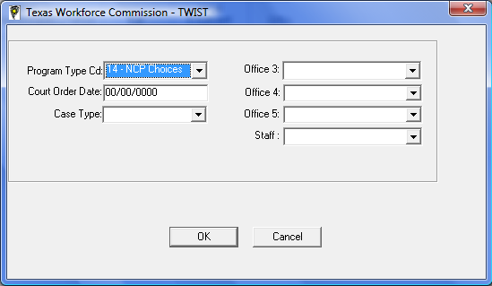

Enter:
Program Type code for the NCP Choices program;
Court Order Date (the NCP was ordered to participate in the program); Case Type (Establishment or Enforcement); and
Office and Staff fields.

B-301.b: TWIST Program Summary Tab
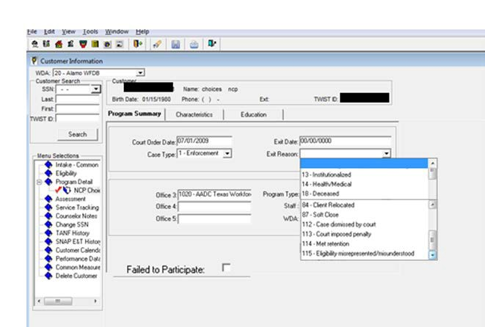

After creation of the Program Detail, enter the participant’s characteristics and education information in the Program Summary tab.

B-301.c: TWIST Characteristics Tab
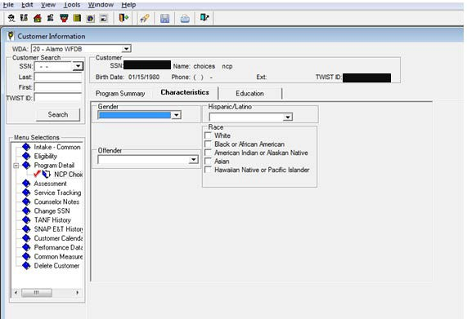

On intake, click on the Characteristics tab to enter the participant’s demographic characteristics—
gender, ethnicity, and offender status.

B-301.d: TWIST Education Tab
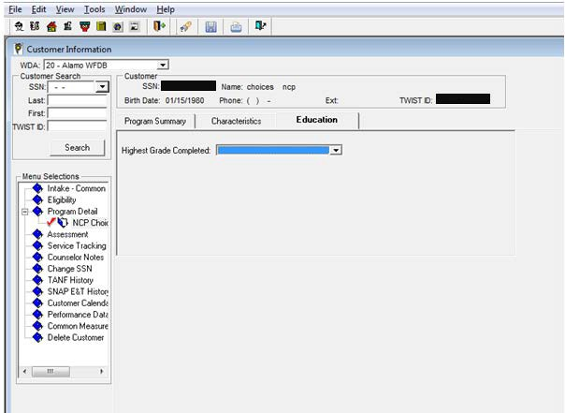

Click the Education tab to enter the participant’s education information.

B-301.e: TWIST Services Tracking Tab

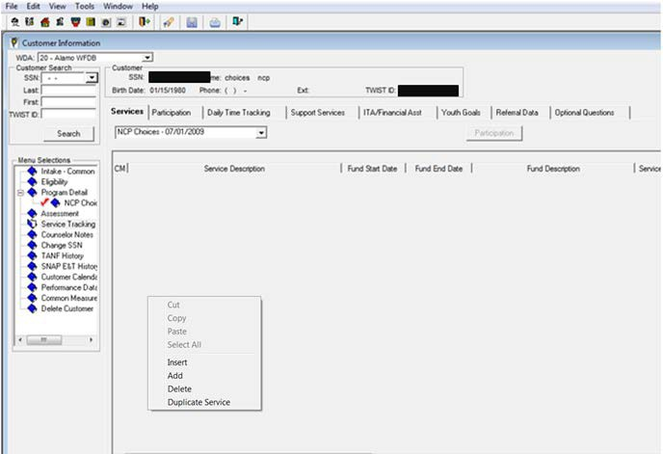

Boards must ensure that Workforce Solutions Office staff tracks services performed for or provided to an NCP Choices participant by entering the services into TWIST using the Services tab.

Enter NCP Choices fund code 179 – NCP Choices to indicate the service was provided through the NCP Choices program. TWIST automatically creates periods of participation based on the services a participant receives and when the participant received them.

To add a service:

• click on the Services tab;
• place the cursor below the column heading and right-click; and
• select Add or Insert from the shortcut menu that appears. The Service Information window displays.

B-301.f: TWIST Service Information Screen

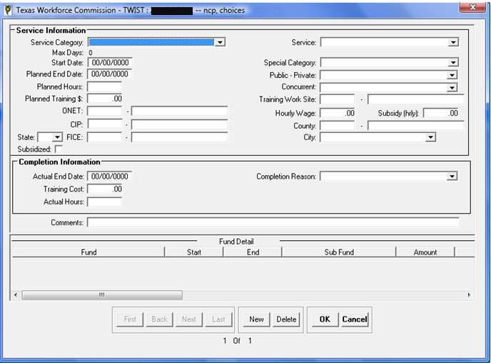

At a minimum, fields that must be completed for each service include the following:

• Service Category—Select the service category.
• Service—Select the service.
• Start Date—Enter the start date of the service.
• Planned End Date—Enter the planned end date of the service.
• Actual End Date—When the service is completed, enter the actual end date of the service.
• Completion Reason—Select the reason the NCP Choices participant stopped participating in the service.
• Comments—Enter comments up to 255 characters.
• Fund—Enter fund code 179 – NCP Choices for each service.

B-301.g: TWIST Fund Detail Fields
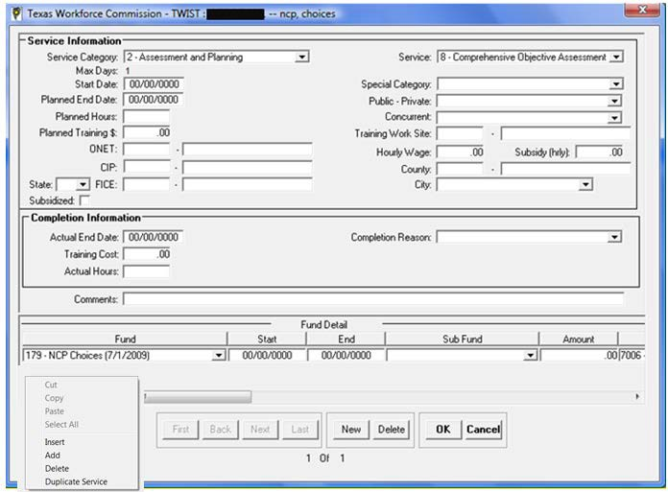

To add the NCP program fund detail, right-click in the space below the column headings and then select Add or Insert from the shortcut menu.

Fields that must be completed for each service include the following:

• Fund—Select 179 – NCP Choices as the funding source paying for the service.
• Start—Enter the start date of the funding source pay period.
• End—When the fund ends, enter the end date of the funding source pay period.

*Office 3—Select the Office 3 you want to assign the service.
*Staff—Enter the staff person.
*These fields are visible when you scroll to the right in the above screen. Click on the New button to add another service. Click on the OK button when finished.

To add a duplicate service:

• click on the Services tab, then click on the service you want to duplicate; and
• right-click in the space below the column headings and select Duplicate Service from the shortcut menu.

TWIST opens a new Service Information window duplicating all the information from the selected service row except for the Start Date, Planned End Date, Actual End Date, fund Start, and fund End. Enter changes and necessary information as appropriate.

B-301.g(1): Allowable Services

Service Code | Description
1 | Occupational/Vocational Training*
2 | Basic Educational Skills/ABE*
3 | On-the-Job Training*
8 | Objective Assessment*
11 | Planned Gap in Service
12 | Job Search Assistance*
13 | Case Managed Job Search*
21 | Case Management
24 | Counseling*
27 | LD Diagnostic Assessment
29 | Labor Market Information
30 | Workforce Center Orientation*
32 | Unsubsidized Self-Employment
37 | UI Claims
38 | Job Readiness/Pre-Employment Skills*
39 | Unsubsidized Employment/Employment Entry*
40 | Community Service*
42 | Subsidized Employment*

Service Code | Description
44 | English as a Second Language*
45 | Mentoring*
47 | Unpaid Public Work Experience*
48 | Unpaid Non-profit Work Experience*
49 | Unpaid For-profit Work Experience*
51 | Job Development*
54 | GED*
58 | Entrepreneurial Training
62 | Initial Assessment
68 | Employability Development Plan*
69 | Group Counseling
84 | Short-term Work Readiness Services*
87 | Work-based Literacy*
91 | Determine Good Cause
138 | Bonding Assistance*
139 | WOTC Eligibility*
201 | Health Care
202 | Family/Child Care **
203 | Transportation
204 | Housing/Rental Assistance
205 | Counseling
207 | Other
208 | Substance Abuse Treatment

Service Code | Description
209 | Individual Development Account (IDA)
211 | GED Test Payment
212 | Work-Related Expense
218 | Financial Planning Assistance
219 | Work-related Incentives
*Indicates a qualifying service to be included in Common Measures performance calculations.
**NCP Choices funds cannot be used to provide family/child care services.

B-400: Case Closure
Boards must ensure that Workforce Solutions Office staff does not remove noncompliant NCP Choices participants from the NCP Choices program.

Boards must be aware of the following:

• Except in certain situations [see section B-404.c], an NCP can exit the program only when staff receives confirmation from OAG or the court that his or her case can be closed.
• Timely removal through administrative or court proceedings ensures that the program maintains swift and certain consequences for nonpaying NCPs and prevents inflated caseloads for staff.
• Significant numbers of cases pending removal from the program takes staff away from providing services to NCPs who are motivated to continue in the program.

In the event of noncompliance, Boards must ensure that Workforce Solutions Office staff:

• does not close an NCP’s case until receiving written notification through COLTS or e-mail from OAG or the court that the NCP has been removed from the program; and
• does not accept verbal notification as confirmation for case closure. Boards must ensure that Workforce Solutions Office staff:
• closes the TWIST Program Detail and the COLTS record only after receiving written confirmation that the NCP has been removed from the program; and
• uses the date staff receives notification or confirmation from OAG as the closing date.

B-401: Request to Remove
Boards must ensure that a request to remove is submitted after the NCP is noncompliant for at least 30 days.
Boards must ensure that the following actions be completed during the 30-day noncompliance period:
- OAG must be notified of the noncompliance.
- OAG communication must be documented in TWIST and COLTS notes.
- Weekly attempts to reengage the customer must be completed and documented in TWIST and COLTS notes.

Boards must ensure that Workforce Solutions Office staff submits, by email or mail, a case closure request to the OAG contact using:

• the Request to Remove form (sample); or
• a locally developed form.
Boards must be aware that written Requests to Remove forms can also be provided to OAG during the monthly coordination meetings.

Boards must ensure that locally developed forms or request to remove communication include the following information:

• The Workforce Solutions Office staff member’s contact information (name, address, and phone number)
• NCP’s name
• OAG case number
• Reason for requesting the removal

B-402: Administrative Removals
Boards must be aware of the following:

• After a request for removal of an NCP Choices participant has been submitted to the local OAG child support office, the child support office will review the circumstances of the case and respond to Workforce Solutions Office staff within a reasonable amount of time (usually 10–15 business days).
• OAG child support offices may make the determination that an administrative removal is appropriate and notify Workforce Solutions Office staff of the decision.
• OAG must provide written notification of the removal process through email, in-person, or as a COLTS OAG comment.

Until receipt of notification from OAG regarding administrative removal, Boards must ensure that Workforce Solutions Office staff does not close the case.

B-403: Planned Gap in Service
Boards must ensure that Workforce Solutions Office staff uses TWIST service code 11 – Planned Gap in Service with NCP Choices fund code 179 – NCP Choices to track cases that are pending approval of a request to remove from OAG, or the court to remove noncompliant NCP Choices participants from the program.

For noncompliant NCP Choices participants, Boards must ensure that Workforce Solutions Office staff:

• attempts to reengage the NCP, in accordance with Board policy, prior to submitting a request to remove;
• sends a request to remove to OAG using the locally developed and agreed-upon process;
• closes all NCP Choices services in TWIST for the NCP Choices participant;
• opens TWIST service code 11 – Planned Gap in Service to indicate that the approval to remove the noncompliant NCP is pending; and

• documents all actions in TWIST Counselor Notes and COLTS.

Boards must ensure that Workforce Solutions Office staff reopens TWIST service code 11 – Planned
Gap in Service each month until an approval to remove has been received.

Upon approval from OAG or the court, Boards must ensure that Workforce Solutions Office staff closes all services and program details, including TWIST service code 11 – Planned Gap in Service.

While the request to remove is pending and upon initiation by the noncompliant NCP Choices participant, Boards must ensure that Workforce Solutions Office staff allows noncompliant participants to resume participation in NCP Choices services.

To determine the number of pending requests with OAG, Boards must ensure that Workforce
Solutions Office staff uses TWIST Report 37 – Management Summary.

B-404: Reasons for Removal
The following are reasons for removing an NCP from the NCP Choices program.

B-404.a: Meets NCP Choices Program Requirements
Boards must be aware that when an NCP has met the NCP Choices program requirements (e.g., retained employment for six months), no confirmation from OAG or the court is required to close the case.

Boards must ensure that Workforce Solutions Office staff:

• accurately enters employment outcomes into TWIST;
• enters information into TWIST Counselor Notes and COLTS indicating that the NCP has successfully completed the NCP Choices program;
• closes the case and all services in TWIST by entering the exit date and completion reason as completed successfully in the TWIST Program Detail; and
• closes the case in COLTS by entering the end date in the Date Services Terminated box and saving the record.

B-404.b: Noncompliance with NCP Choices Program Requirements
Boards must determine noncompliance with workforce-related program requirements and submit requests to OAG for case closure based on the following program guidelines:

• If an NCP does not appear for his or her first meeting with Workforce Solutions Office staff or does not return after the first meeting, reasonable and timely attempts (as defined by the Board) must be made to contact and reengage the NCP.
• If an NCP has not met program participation requirements for 30 days, a request to remove the NCP from the NCP Choices program must be made to OAG.

• If an NCP is compliant with NCP Choices program requirements but has not obtained employment after 180 days of participation, a request to remove the NCP from the program must be made to OAG.

B-404.c: NCP Choices Participant Becomes Ineligible or Unable to Participate
If an NCP becomes ineligible or unable to participate in NCP Choices program for any of the following reasons, Boards must ensure that Workforce Solutions Office staff immediately submits a request for case closure to OAG:

• Deceased;
• Jailed on charges unrelated to child support;
• Medically unable to work (the NCP must provide his or her case manager with proper documentation and the medical reason must extend past 30 days);
• Not legally allowed to work in the United States;
• Moved out of the local workforce development area (workforce area); or
• Workforce Solutions Office staff discovers that the NCP does not meet all of the program eligibility requirements.

For deceased NCPs, Boards must ensure that Workforce Solutions Office staff closes WF Status in
COLTS upon receiving verification of the NCP’s death.

To assist with caseload management and adhere to the principle of swift and certain consequences, Boards must ensure that Workforce Solutions Office staff follows the procedures set forth in the following table:

Immediate Case Closure | Immediate Request for Removal | Request for Removal after 30 Days | Request for Removal after 180 Days
Capias has been issued on the child support case.  Motion to revoke has been filed on a child support case.  NCP has retained employment for six months and has graduated from the program.  Note: Notification of case closure must be sent to OAG. | Deceased (documented)  Incarcerated (unrelated to child support)  Disability (documented)  Relocation out of workforce area  Not legally allowed to work in the United  States  Eligibility misrepresented or misunderstood | NCP does not appear for first meeting or does not return after first meeting and does not respond to outreach.  Note: In above instances, Workforce Solutions Office staff checks the *Failed to Participate box in the TWIST Program Detail.  NCP has not complied with program requirements. | NCP is actively participating in the program but is still unemployed after six months.
*Boards must ensure that Workforce Solutions Office staff uses the Failed to Participate checkbox only in cases where an NCP does not appear for, or return after, his or her first
meeting with Workforce Solutions Office staff.

B-404.c(1): TWIST Program Summary Tab

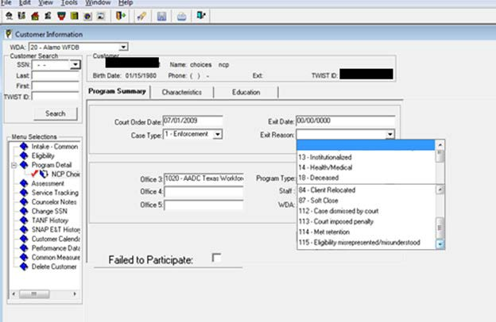

Boards must ensure that Workforce Solutions Office staff uses one of the following Exit Reasons for the NCP Choices program:

• 13 – Institutionalized—when an NCP is incarcerated for reasons not related to child support;
• 14 – Health/Medical—when an NCP exits due to a documented health or medical issue that prevents him or her from actively participating in NCP Choices;
• 18 – Deceased;
• 84 – Client Relocated—when an NCP moves out of the NCP Choices program service area after being ordered to participate;
• 112 – Case dismissed by court—when an NCP is no longer required to participate in the NCP Choices program. NCPs may or may not be in compliance with the workforce requirements of the NCP Choices program;
• 113 – Court imposed penalty—when a capias is issued, a motion to revoke is filed, or an
NCP is incarcerated for nonpayment of child support;
• 114 – Met retention—when an NCP has successfully completed the requirements of the NCP Choices program, including retaining employment for six months; or

• 115 – Eligibility misrepresented/misunderstood—when an NCP is inadvertently ordered to participate in the program (e.g., NCP ordered to participate does not have a Social Security number, NCP is not legally able to work in the United States, NCP lives outside the service area, or NCP is disabled).

Note: While the menu includes 87 – Soft Close, Boards must ensure that Workforce Solutions Office staff never uses this Exit Reason; program details will never be “soft closed.”

B-500: NCP Choices Performance Measures
Performance measures are important indicators of progress toward meeting the goals of the NCP Choices program. The Boards are expected to meet the following performance measures:

• Meet or Exceed 65 percent Entered Employment
• Meet or Exceed 50 percent Employment Retention

Exiters are defined as individuals who received a service while participating in the program and exited for the one of the following reasons:

• Case Dismissed
• Court Imposed Penalty
• Closed Successful

Exiters who obtained employment count toward the Entered Employment performance measure by the end of the 1st calendar quarter after exit.

NCPs who were employed are counted toward the Employment Retention performance measure in the 1st calendar quarter after exit and are employed in the 2nd and 3rd calendar quarters after exit.

NCPs who exit for the following reasons are excluded from performance calculations:

• Non-compliance
• Invalid SSNs (e.g., 999-99-9999)
• NCPs who at exit or during the quarter following the quarter of exit are deceased, or for at least 90 days, are:
- institutionalized;
- called to active military duty;
- receiving treatment; or
- providing care to a family member

Any time an NCP is provided with a qualifying service, he or she becomes a participant for Common Measures performance. Since most services provided by the program fall into this category, Boards must ensure that Workforce Solutions Office staff enters all service information completely, accurately, and timely.

However, because NCP Choices participants are only included in Boards’ overall performance, the impact on Boards’ respective performance measures is insignificant (less than 1/100th percent).

Further details on which NCP Choices allowable services are qualifying services can be found in section B-301.g(1) of this guide.

B-600: TWIST Web Reports
NCP Choices program data is available through TWIST Web Reports. The performance measures used for the NCP Choices program are calculated using a different methodology from that used to calculate Common Measures. To retrieve NCP data, Boards must ensure that Workforce Solutions Office staff filters by fund code 179 – NCP Choices:

• 1 Active List—individuals with open program details and open services. The report can be sorted by participant name and service Start Date and filtered by Office, Staff, Fund, and Service.
• 76 Case Load Report—individuals with open program details and their current status. The report can be sorted by participant name and service Start Date and filtered by Office, Staff, Fund, and Service.
• 35 Inactive List—individuals with open program details, but no open services. The report can be sorted by participant name and last service End Date and filtered by Office, Staff, Fund, and Service.
• 27 Support Services Report—unduplicated counts of support services by type and calculates the average payment per support service instance.
• 37 Management Summary Report—detailed unduplicated counts of customers’
services and characteristics.
• 220 Non-Custodial Parent Choices Report—used as a management tool for the NCP Choices program and is the source of official program performance calculations. The following are calculated for the report period requested:
➢ Caseload
➢ Number Served
➢ Obtained Employment Rate
➢ Retained Employment Rate
➢ Average Hourly Wage
➢ Average Weeks to Employment
➢ Participation rates
➢ Demographic information

Part C – Frequently Asked Questions

C-100: NCP Choices Orders and Eligibility
Q: Can we work with noncustodial parents (NCPs) who don’t have valid IDs?
A: Yes. If an NCP does not have a valid driver’s license or has a suspended license, Workforce Solutions Office staff may still provide NCP Choices services to that individual. The NCP must:

• have a Social Security number;
• have the ability to work (not on work release or in jail);
• owe child support (Establishment (EST) or Enforcement (ENF) case); and
• be unemployed or underemployed.

Q: Can an NCP be ordered into NCP Choices if he or she is already ordered to participate under a separate case or by another Office of the Attorney General child support office?
A: No. An NCP cannot be ordered by another Office of the Attorney General (OAG) child support office if he or she is currently enrolled in the NCP Choices program.

Note: A child support office can have participation language in multiple orders on the same date if those cases are all handled by that particular office, but two different offices cannot order a parent
in on separate dates. Also, once the first order is closed, the NCP may be reordered into the program by a different child support office in the future.

Q: What happens if an NCP refuses to participate in the program after he or she is ordered in?
A: If an NCP is ordered into the program but refuses to participate, Local Workforce Development Boards (Boards) must ensure that Workforce Solutions Office staff:

• creates a Program Detail in The Workforce Information System of Texas (TWIST) for the NCP and enters initial order-in information;
• records TWIST service 62 – Initial Assessment if intake occurred in court and opens a Choices Online Tracking System (COLTS) record; and
• attempts to contact the NCP to encourage participation.
If the NCP isn’t compliant within 30 days, Boards must ensure that Workforce Solutions Office staff requests removal following the request to remove the procedure as provided in this guide. Once the request is approved by OAG, staff can check the failed to participate box in TWIST.

Q: Is an incarcerated NCP eligible for the NCP Choices program?
A: For an incarcerated NCP to be eligible for NCP Choices, the NCP must:

• be incarcerated for child-support–related matters (e.g., arrested for not appearing in court for child support, jailed for nonpayment);
• be released from jail within 24–48 hours; and
• not have any other criminal charges that would keep him or her in jail.

Boards must ensure that case managers are able to meet face-to-face in court with NCPs at the time of the order.

Note: An NCP is ineligible for the program if he or she is incarcerated on criminal charges not related to child support at the time of the order.

Q: What happens if an NCP is sentenced to jail AFTER he or she is ordered into the NCP Choices program?
A: If the NCP is jailed due to child-support–related matters after enrollment and is incarcerated for
30 days or less, he or she can remain in the program. If the NCP is jailed for more than 30 days, Boards must ensure that case managers request removal from OAG. If after enrollment in NCP Choices an NCP is jailed due to criminal charges that are NOT related to child support, Boards must ensure that case managers immediately request removal. Once the NCP is released from jail, the judge may or may not reorder the NCP into the program.

Q: If an NCP is committed to jail and the case needs to be closed, is it closed as “institutionalized” or as “court-imposed penalty” in TWIST?
A: If the NCP is incarcerated for a child-support–related reason, the case must be closed as “court-
imposed penalty.” If the NCP is jailed for a reason that is not child-support–related, then the case may be closed as “institutionalized.”

C-200: NCP Choices Procedures and TWIST Documentation
Q: When do case managers check the TWIST Failed to Participate box?
A: Case managers check the TWIST Failed to Participate box in two instances:

• if the NCP shows up for his or her first meeting and never comes back; or
• if the NCP never shows up after being ordered in.

Q: If an NCP obtains employment, what do we document?
A: Once an NCP obtains employment, case managers verify employment then enter the information into TWIST Employment Outcomes and Counselor Notes. Employment Outcomes is updated monthly. Additionally, case managers document employment and verification into OAG’s COLTS Notes.

Q: What happens if an NCP loses his or her job before the six-month tracking period is up?
A: If the six-month tracking period has not yet expired from the date the NCP first entered employment, then the NCP must be placed in work activities again.

Note: If six months elapse from the date the NCP first enters employment, then the case should be closed whether or not the NCP obtains subsequent employment. OAG must be notified if the case is closed.

Additionally, if the case is closed and the NCP is reordered into the program a second time, and then obtains employment, the employment retention period starts over.

Q: If an NCP is employed, but fails to comply with the monthly contact procedures, is this necessarily considered noncompliance?
A: If a case manager is able to verify an NCP’s employment through another source for the six- month tracking period, he or she can still get credit for the retention. However, we strongly suggest that case managers continue to encourage their NCPs to maintain monthly contact once they’re employed.

Q: We are instructed to request case closure after 30 days for NCPs who have not participated in the NCP Choices program. Does this still apply if our local workforce development area’s (workforce area) judge sets compliance hearings after 30 days?
A: No. This guidance does not apply to a workforce area when a judge sets compliance hearings after the 30-day period. Case managers wait until after the compliance hearing to see if the judge grants the NCP continuance in the NCP Choices program, sets future compliance hearings, or sentences the NCP to jail, etc. If there are no further actions taken by the judge after the compliance hearing and the NCP is still not in compliance, you can request case closure.

Q: If Workforce Solutions Office staff determines upon assessment that an NCP is not job ready due to what appears to be either a physical or mental disability, can the NCP be removed from the NCP Choices program?
A: NCPs who have been ordered into the NCP Choices program and appear to have mental or physical disabilities during assessment are not exempt from participating in the program unless the NCP provides the case manager with documentation of the physical or mental disability (e.g., doctor’s note, receipt for Social Security Insurance). If no documentation is provided, the case manager continues to the serve the NCP and the case remains open. Case managers cannot request closure for these specific cases on their own determination that the NCP is unable to work.

Q: For establishment cases, what TWIST Exit Reason do we use if none of the reasons for the NCP’s noncompliance really applies?
A: Case managers use Exit Reason 112 – Case Dismissed by Court as a generic reason since it can be applied to cases in which NCPs have not been incarcerated, have not relocated, etc.

C-300: Additional Services Offered for NCP Choices Participants
Q: Is the Work Opportunity Tax Credit still an option for NCPs?
A: The legislative authority for the WOTC program, which had expired on December 31, 2014, was extended for five-years (from January 1, 2015, to December 31, 2019) and retroactively reauthorizes the program for new employees hired on or after January 1, 2015. Employers should continue to submit WOTC applications for staff hired after December 31, 2015, within 28 calendar days of the new hire’s start date. DOL has released two updated two versions of the Individual Characteristics form, ETA Form 9061, with revision dates of April 2013 and July 2013. Based on DOL guidance, TWC will only be able to accept either of the two current versions of ETA Form 9061. All other past versions of the form are obsolete.

Q: Should we give NCPs the Test of Adult Basic Education?
A: Giving NCPs the Test of Adult Basic Education (TABE) is not required, but each Board can TABE-test their NCPs if they find it beneficial.

Q: Can we provide child care assistance under NCP Choices?
A: Child care is not an allowable support service for the NCP Choices program. Customers will need to meet child care services eligibility and authorization for subsidized child care.

Q: Can we assist NCPs with traffic tickets, surcharges, etc.?
A: No. We cannot pay fines, surcharges, penalties, etc., that are not related to child support.

Q: Can we pay for eye exams under the NCP Choices program?
A: Eye exams are considered a medical expense and are not an NCP Choices allowable cost.

Part D – List of Revisions
Note: The guide contains minor, non-substantive editorial changes that are not included on the List of Revisions.

MONTH 2019 Revisions
SECTION | COMMENTS
List of Acronyms | Adds EST, Established Case, and ENF, Enforcement Case, in regard to NCP participation orders
A-200 | Clarified definition of Administrative Income Withholding (AIW) and The Workforce Information System of Texas (TWIST)
C-300 | Updates the effective dates for the Work Opportunity Tax Credit (WOTC) program

January 2016 Revisions

SECTION | COMMENTS
 | All sections of the guide have been renumbered.
List of Acronyms | Adds list of common acronyms used throughout the guide.
A-101 | Renames title from Legislative Authority to Applicable Contract  Authorities and clarifies the applicable federal authority citations.
A-102 | Adds in-person to specify the type of weekly contact with NCPs.
A-103 | Adds information regarding OAG funding.
A-104 | Adds that eligible NCPs include non-public assistance cases as well as  public assistance cases.
A-105 | Updates results to date through August 2014.
A-106 | Adds new section to introduce the NCP Choices PEER Demonstration.
A-200 | Adds definitions of NCP Choices Acronyms and Terms.
A-301 | Updates frequency of site visits to regular rather than quarterly. Adds  that purpose is to identify necessary program enhancements and best

SECTION | COMMENTS
A-302 | Adds OAG responsibility to expedite removal of noncompliant NCPs from  the program.
A-303 | Adds an introductory paragraph to Board responsibilities.
A-304 | Adds a responsibility of Workforce Solutions Office staff to attend  subsequent compliance hearings and provide testimony as needed. Clarifies that timely data entry occurs within three business days.
A-306 | Clarifies that NCPs must participate for an average of 30 hours per week  and that in-person meetings occur weekly until employed.
A-600 | Removes map of existing NCP Choices sites and Child Support Offices and  updates with table that provides NCP Choices Service Delivery Areas.
B-100 | Clarifies:  NCPs actively participate for an average of 30 hours per week; Weekly in-person contact with NCPs until employed;
B-101 | Adds written NCP Choices process that accompanies flowchart
B-102 | Modifies language relating to monthly goals for the number of NCPs  ordered into the program.  Clarifies that receipt of a signed copy of the order by Workforce Solutions
B-106 | Clarifies that NCPs participate an average of 30 hours per week.  Removes the requirement for community service after an initial four
B-106.e | Removes subsidized employment with a public-sector employer.
B-106.e | Adds a definition of full-time employment.
B-106.f | Adds Unsubsidized Self-Employment as an allowable work activity.  Provides criteria for verification of established and prospective self- employment enterprises and ongoing verification.
B-106.h | Adds the requirement that vocational educational training is directly related to a demand occupation.
B-106.i | Removes the stipulation that distance learning must be performed in a  supervised setting.
B-106.j | Adds statement that community service is no longer required after the  initial four weeks of activity.
B-107 | Adds new section on the Work Opportunity Tax Credit (WOTC) and  fidelity bonding services.

December 2015 Revisions
SECTION | COMMENTS
B-204 | Adds requirement for Boards to develop guidelines and strategies for the  use of non-recurrent short-term benefits.
B-301 | Incorporates the NCP Choices TWIST Quick Reference Guide.
B-303 | Adds Section on TWIST Counselor Notes. Aligns with guidance issued in
B-305 | Creates separate section on documentation to be maintained in case files.
B-402 | Adds new section on administrative removals.
B-403 | Adds new section on planned gap in service in accordance with
Part C | Adds Frequently Asked Questions section.

SECTION | COMMENTS
Replaces Workforce Investment Act (WIA) with Workforce Innovation
and Opportunity Act (WIOA) throughout Guide.
Change to | Replaces “Release Notes” with “Technical Assistance Bulletins.”
A-104 | Deletes “Be delinquent in child support payments.”
A-105 | Updates program date for results, number of NCPs served, and amount  collected.
A-200 | Changes the terms “Obtained employment” to “Entered Employment” and  “Retained Employment” to “Employment Retention,” now based on  Common Measures methodology.
A-600 | Updates month and year.
B-500 | Changes the terms “Obtained employment” to “Entered Employment,”  and “Retained Employment” to “Employment Retention.”
B-500 | Removes TWIST Report #220. Adds TWIST Report #142 CM Adult  Entered Employment, TWIST Report #144 CM Employment Retention, and TWIST Report #158 CM Employment Retention Forecast.
B-500 | Changes reasons for exclusions in regards to performance calculations.
B-500 | Adds when Entered Employment and Employment Retention are

C-300 Updates information about WOTC.

April 2019 NCP Choices participant data provided by Workforce Technical Assistance.

